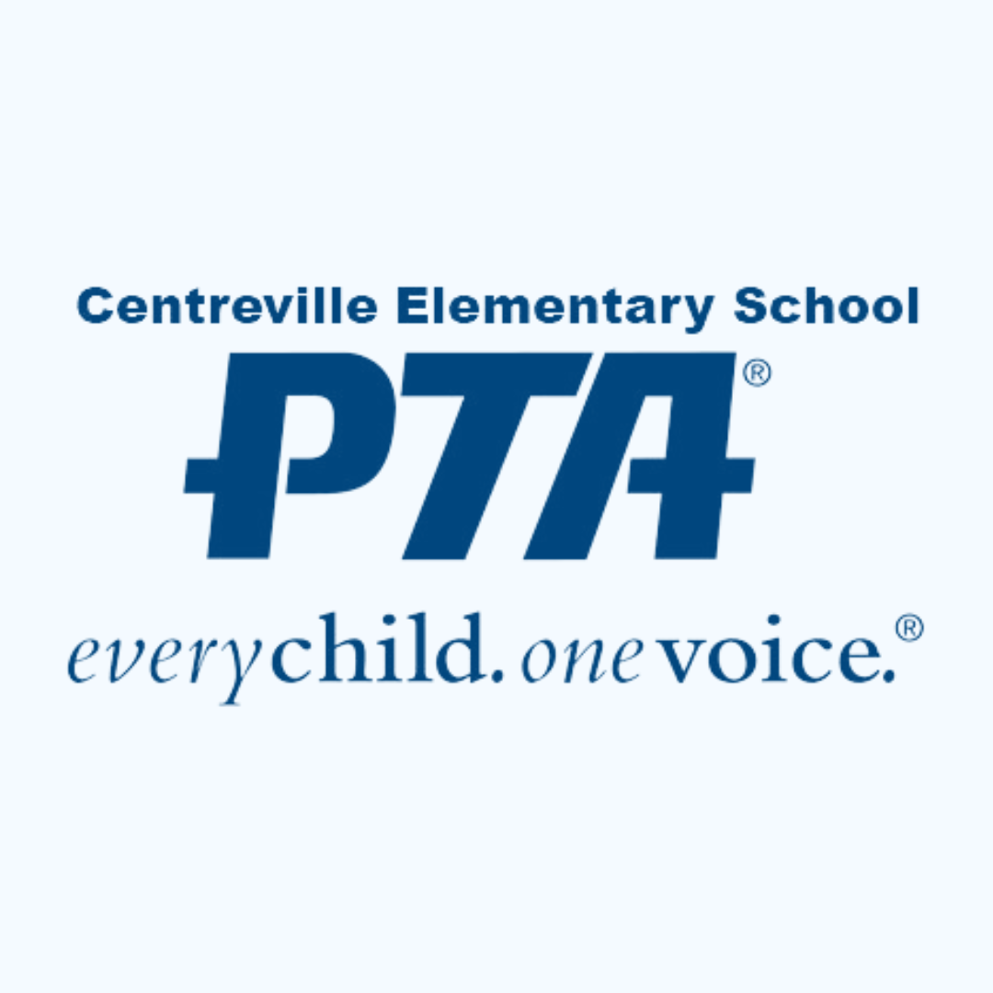

**TEACHER & STAFF GRANT REQUEST FORM**

The Centreville Elementary PTA Teacher & Staff Grant Program supports student learning by meeting the needs of teachers and staff. It funds up to $100 per year for unique or innovative programs or resources; collaborations between teachers; instructional materials; and more. It does not fund items already in the school budget. All requests must directly benefit the students at Centreville Elementary School. Any materials purchased with PTA funds are considered to be property of Centreville Elementary School; they must remain at the school if the requester should ever leave.

Approval by the Principal must be obtained prior to submitting this request.

The PTA Executive Committee will review the request and notify you of its final decision. Once approved, you will need to submit an Expense Reimbursement Form along with any receipts to substantiate the purchase. If you have any questions, please contact the PTA Treasurer at [treasurer@centrevillepta.org](mailto:treasurer@centrevillepta.org).

|  |  |  |  |
| --- | --- | --- | --- |
| **Requestor’s Name** |  | **Date of Request:** |  |
| **Requestor’s Email:** |  | **Date Funds Needed:** |  |
| **Requestor’s Phone:** |  | **Amount Requested:** |  |
| **Please give a general description of items to be purchased:** | | | |
|  | | | |
| **Describe how your request will support our students’ health, wellbeing, or educational success?** | | | |
|  | | | |
| **How many individuals will this grant benefit?** | | | |
|  | | | |

Principal Approval Date Approved

**\*\* FOR PTA USE ONLY \*\***

Executive Committee Recommendation: ▢ Approved ▢ Declined

Signature of President Signature of Treasurer